

**DAYANANDA SAGAR COLLEGE OF ENGINEERING**

*(An Autonomous Institute Affiliated to VTU, Belagavi)*

Shavige Malleshwara Hills, Kumaraswamy Layout, Bengaluru-560078

**DEPARTMENT OF ELECTRONICS AND COMMUNICATION**

**Report on**

**Management & Entrepreneurship**

(18HS5ICMEP)

**LEARNTECH STARTUP PROJECT**

in collaboration with

**WHITE-HAT JR.**

**(CODING LEARNING PLATFORM)**

Presented by

**SAMEER GAUTAM**

**1D18EC143**

**5th Semester**

**Department of ECE**

**Dayananda Sagara College of Engineering**

**TABLE OF CONTENTS**

1. **ACKNOWLEDGEMENT**
2. **ABSTRACT**
3. **INTRODUCTION**

* **Challenges faced**
* **Language Barriers in Using Online Platforms**

1. **MARKET POTENTIAL**

* **Existing potential**
* **Future scenario**

1. **BASICS AND STANDARDIZATION**
2. **SETTINGS AND SETUP**

* **Preschool**
* **Primary and secondary**
* **Higher education**

1. **BENEFITS AND DISSADVANTAGES**
2. **EXPENDITURE AND REVENUE**
3. **DESCRIPTION OF PRODUCT.**
4. **CONCLUSION**
5. **Acknowledgement**

I am overwhelmed in all humbleness and gratefulness to acknowledge my depth to all those who have helped me to put these ideas, well above the level of simplicity and into something concrete. All that I have done is only due to such supervision and assistance and I would not forget to thank them.

I would like to express my special thanks of gratitude to my teacher **Mr. PRADEEP MN,** Assistant Professor, Dept. of ECE as well as our HOD **Dr. T.C MANJUNATH** who gave me the golden opportunity to do this wonderful project on the topic "Educational Startup", which also helped me in doing a lot of Research and I came to know about so many new things. I am extremely thankful to her for providing such a nice support and guidance.

I am highly indebted to and fortunate enough to get their guidance and constant supervision and support from all Teaching staffs of **Department of Electronics and Communication** which helped us in necessary information for successfully completing our project work. Also, I would like to extend our sincere esteems to all staff in laboratory for their timely support.

**SAMEER GAUTAM**

**1DS18EC143**

1. **ABSTRACT**

According to the New Education Policy that has been approved by the Narendra Modi-led National Democratic Alliance (NDA) government, students will be taught Coding as a subject from as early as class 6th. School Education secretary Anita Karwal said students of class 6 and onwards will be taught coding in schools as a part of 21st-century skills.

The announcement was made in by Education Ministry officials at a press conference in the presence of Union Minister Prakash Javadekar. Through coding, students can learn to create games and applications for multiple platforms such as Android, Windows and iOS.

Hence this project mainly focuses on developing a web based platform and a mobile application to how to gain basics in coding. The WhiteHat Junior’s mission is to empower a whole generation to become creator versus consumer of technology. WhiteHat Jr teaches fundamentals of coding – logic, structure, sequence and algorithmic thinking to enable kids to generate creative outcomes e.g. websites, animations and apps.

­­­

1. **INTRODUCTION**

From the introduction of content management platforms to the launch of interactivity apps and,all the action in between, LearnTech startups are gaining wide popularity and rightly so, because they have made learning and education so much fun.However, startups need to tackle a range of educational technology challenges in order to be successful.

* **CHALLENGES FACED :**

As entrepreneurs and startups associated with the education system, it is also important to understand the education system.You need to be in permanent touch and evolve with them to fully understand all school challenges or comprehend the varied needs of students and teachers. Many LearnTech platforms lack critical inputs from teachers, as well as transparency. Without having a deeper insight into how students learn and how classroom technology impacts learning outcomes, it is tough to address these challenges.

Designing a flawless and easy-to-follow UX is a great challenge that most startups face. We can say that most LearnTech startups lack properUI and UX. This makes it hard for the end users to understand and grasp the system. In most cases, teachers find the use of apps and platforms a bit difficult, while students are not used to the AR/VR used in tech.

Undoubtedly, the LearnTech industry is growing at a rapid rate. This makes startups believe that the industry guarantees bright prospects. However, what most of them forget is the ever-rising competition in the field. There are hundreds of competitors in the market, which makes it tough to stand out and look original.

**CHALLENGES FACED BY LEARNTECH START-UPS IN TIER II AND TIER III INDIAN CITIES :**

The Tier III and Tier II cities in India have seen tremendous growth in the realm of internet usage, but it is mostly limited to the use of smart phones and social media. They are not early users of the internet and computer devices and have limited knowledge. The need of the hour is dumbed-down products that have behavioral UX suitable to the end-user. This remains a challenge for the industry. The problem is to produce relevant and meaningful educational content that is accepted and understood.

There are many instances that the most obvious thing in the digital space is entirely unobvious for the semi-urban user. The student often is not curious and explorative. The aspiration and need to access the technology-based application is often not attractive enough to woo the student. The dependence on traditional learning systems is too grounded to allow a smooth transition to the digital space.

There is no obvious solution, but to use traditional marketing campaigns to get students online. LearnTech ventures need to create user-friendly UX that makes the technology easy to apply.

* **LANGUAGE BARRIERS IN USING ONLINE PLATFORMS FOR EDUCATION:**

Vernacular is still the language of choice in the hinterland of India. The policy of public education is to focus on the regional language. Most people use the local language for communication. India is a land where over 50 languages and thousands of dialects are used. This makes communication difficult.

Students have a smattering of knowledge of English and most uncomfortable in using it as a language for effective learning. Retention and stickiness are affected if the language is not in the comfort zone. The student might be able to read the content in broken English, but comprehension levels remain low. The desired result is not forthcoming, so learning is deemed a failure. This makes the student prefer local coaching in offline mode to be able to study in the local tongue.

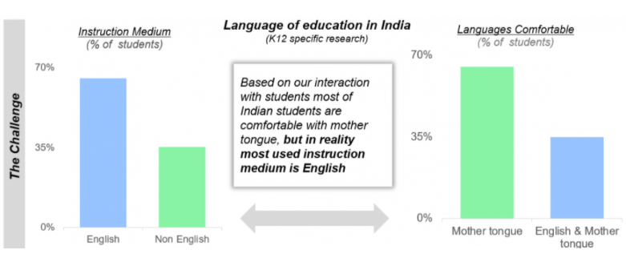

**Figure 3.1**

The only solution is to translate the courses offered by LearnTech start-ups in the major regional languages to improve student loyalty and result.The few ventures in the industry that have managed to address these vital concerns are moving forward to make massive inroads in Tier II and Tier III cities. Revenue breadth has increased, and marketing campaigns are successfully implemented.

1. **MARKET POTENTIAL**

**• EXISTING POTENTIAL**

Indian startup ecosystem for over seven years, and it is exploding with mega funding rounds. In 2017 Indian tech startups raised nearly $10 Billion in funding

Between 2013 and 2015, investors have consistently increased their investments in the global LearnTech industry, and it hit a record high of $3.44B in funding in 2015. In 2016, the number of deals in ed tech decreased by 17% globally with a 32% reduction in funding value globally. It again hit a record number of deals in 2015 and then a dip in 2016 through Q2 2017.

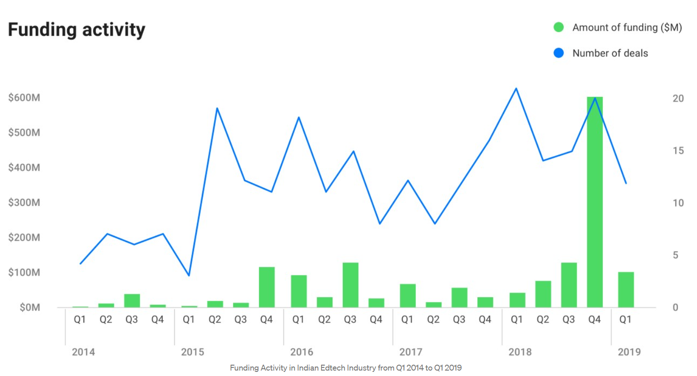

**Figure 4.1**

The Q4 2018 empire state building in the funding activity chart’s reason some successful LearnTech startups — India’s Ed tech unicorn.

India’s population growth and relative underinvestment in education was becoming apparent. In 2000-01 relative to 1990-91, the number of Indian colleges as well as the enrollment in those institutions doubled. Due to all this, the return on education increased for the average Indian. The constraints of geography, poor quality teachers or lack of mentors which restricted the academic potential of students in Tier III and Tier II markets were slowly dismantling. The premium for education was increase almost 50% towards early 20’s.

But moving to learn online was a massive behavioral shift and efforts had to be expended to make the market ready to adjust to such a shift. Startups realized the inherent challenges associated with online learning.

With a high degree of overlap in the primary education curriculum across countries, many K12 content platforms were creating contents. These startups were looking to replicate necessary schooling elements like personalized service, feedback & counseling as part of their product offerings.

They are further referring to post K-12 market including engagement through gamification, personalized learning, peer learning and outcome measurement became the factors for competitive differentiation.

As current report by RedSeer & Omidyar Network revealed that LearnTech users - both paid and free unique users - in K12 and post K-12 segment have seen an increase, with the user base doubling from 45 million to 90 million from 2019 to 2020.

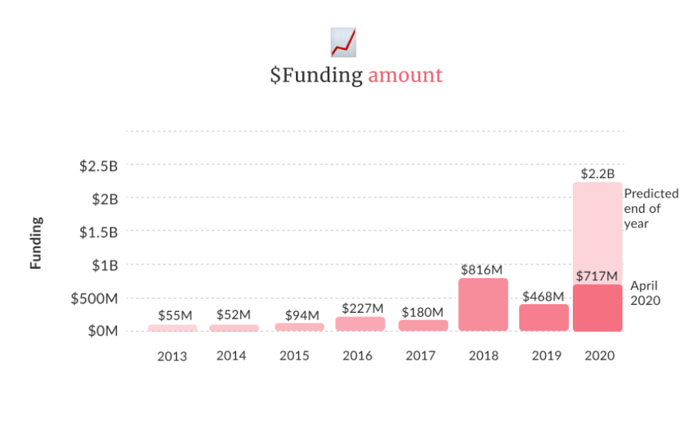E-learning, online courses, training for Undergraduate and postgraduate degrees and working professionals opting for upskilling and/or reskilling courses are giving the boost for the LearnTech Industries. This shows that LearnTech startups had finally started to take off.

**Figure 4.2**

* **FUTURE SCENARIO**

LearnTech startups are looking to capitalize on the opportunity in education enterprises - schools, colleges, coaching institutes and more are filling these gaps in access to education or provision of online learning classes. As more and more schools go online and rely on virtual classrooms, the adoption of LearnTech B2B services and products will grow, just as the adoption in enterprise tech tools has grown in the past 6 months.

Moreover, the gap in quality of education delivered in private school and the public institutions is increasing every year, as per the Annual Status of Education Report (ASER), which found that among fifth-grade students only 23% could solve a simple division problem in government schools, while this number was 40% in more expensive private schools.

Hence, The NEP 2020 recognizes the need to leverage the advantages of technology while acknowledging its potential risks and dangers. It emphasizes the need for carefully designed pilot studies to determine the benefits of online education. The existing digital platforms are to be optimized and expanded to meet challenges with the aim of providing quality education for all. To this end, the focus on the Digital India Campaign will be ramped up and teachers will be given the required training to become effective online educators.

India's working-age population accounts for 67% of its total population of 1.3 billion people, which makes it imperative for ed-tech companies to expand their focus to include skill development initiatives, the report says. The right tech skill sets and certification are the two most important parameters for tech employment. It is to be noted here that the demand side of ed-tech is robust.

Taking into account that the pandemic has brought plenty of momentum for LearnTech adoption in India, the market size of LearnTech in India is estimated to grow 3.7x in the next five years, from $2.8 Bn (2020) to $10.4 Bn (2025).

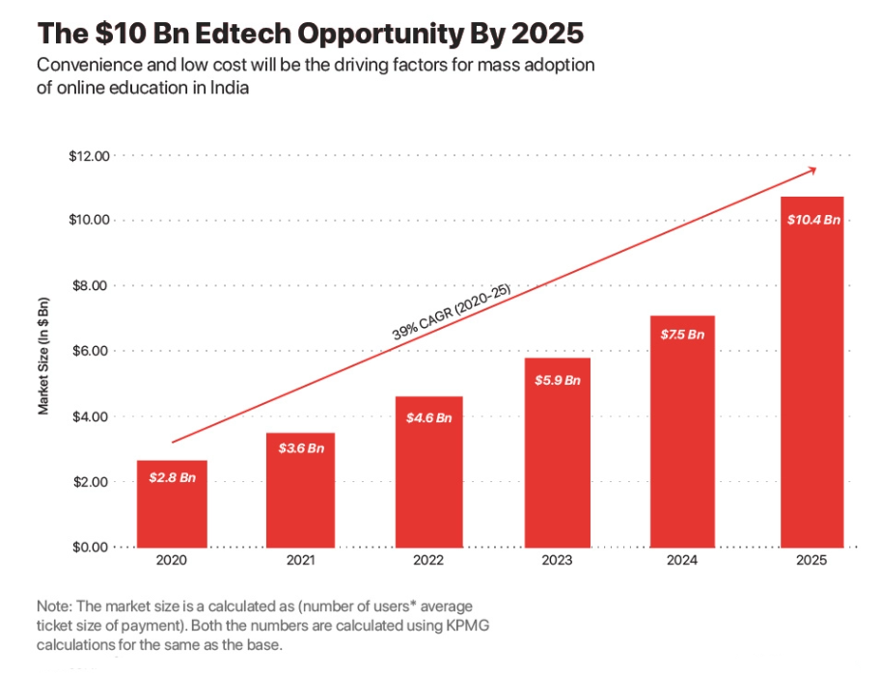

**Figure 4.3**

With growing adoption during the lockdown months, LearnTech services and products are expected to have an addressable base of 37 Mn-plus paid users by 2025 (India to have 37 Mn + Paid LearnTech User BT 2025.) and for 202o it is set to gain the estimation for 2.3B till the end of year .

According to the Indian Ministry of Human Resources, the country's school system has 1.3 million schools that annually teach an estimated 250 million students. Which gives us estimation of 228 funding round that have raised $2.3 billion to date this year. The latest was a $100 million series D funding obtained by LearnTech companies.

2016 was the demonetization moment not only for fintech, but also LearnTech. The Reliance, Jiofication which led to a massive surge in data use gave a booster shot to LearnTech by finally solving the access problem, with 850M mobile phone user’s majority of which were youngsters, India was ready to make mobiles the classrooms of tomorrow.

Among the LearnTech sub-sectors, K-12 education startups with $4.3 Bn in total market size will have the single highest market share — 41% of the total LearnTech market in India.

Besides K-12 education, for kids and younger students, coding is the next frontier as a slew of startups are looking to gain headway in this segment. LearnTech startups in the coding and programming segment have come into the limelight WhiteHat Jr acquisition. Other K-12 players brought in coding lessons to capitalise on this wave.

1. **BASICS AND STANDARDIZATION**

The recently published National Education Policy 2020 also stresses on integration of technology across classrooms and proposes creation of an autonomous body, the National Educational Technology Forum, to provide a platform for the free exchange of ideas on use of technology to enhance learning.

Education sector in India is highly regulated. Most of these regulations apply to traditional educational institutions providing K-12 or higher education. Majority of the LearnTech players in India focus on K-12 curriculum and competitive exams training and most of their customers are minors. Under Indian laws, minors (i.e. individuals below the age of 18) are not competent to enter into contracts. Therefore, the LearnTech service providers need to ensure that they enter into appropriate binding documentation with the parents or legal guardians of the students, to be able to enforce the terms, conditions and policies for use of their platforms.

**BASICS :**

* **Basics Learning objects standards**

Much effort has been put into the technical reuse of electronically based teaching materials and, in particular, creating or re-using learning objects. These are self-contained units that are properly tagged with keywords, or other metadata, and often stored in an XML file format. Creating a course requires putting together a sequence of learning objects.

There are both proprietary and open, non-commercial and commercial, peer-reviewed repositories of learning objects such as the Merlot repository. Sharable Content Object Reference Model (SCORM) is a collection of standards and specifications that applies to certain web-based e-learning. Other specifications, such as Schools Interoperability Framework, allow for the transporting of learning objects, or for categorizing metadata (LOM).

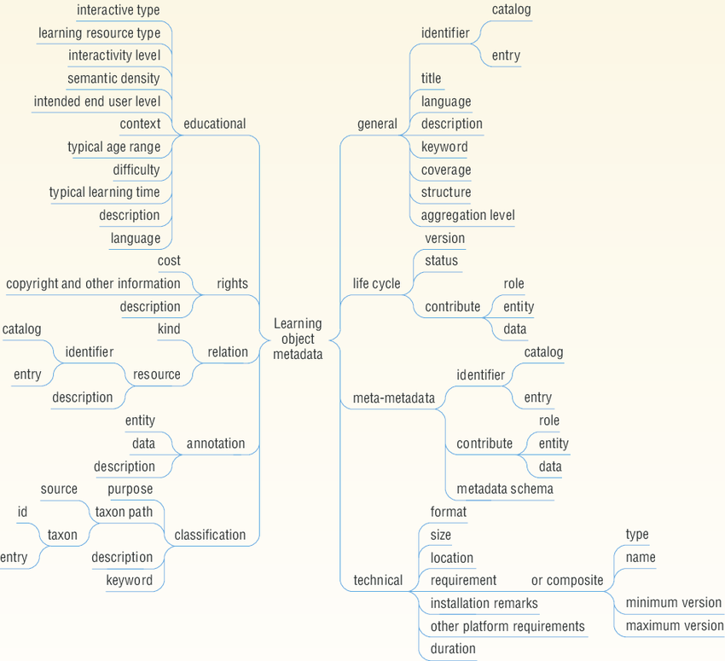

**Figure 5**

**STANDARDIZATION:**

* **Artificial intelligence**

As artificial intelligence (AI) becomes more prominent in this age of big data, it has also been widely adopted in K-12 classrooms. One prominent class of AI-enhanced educational technology is intelligent tutoring systems (ITSs), designed to provide immediate and personalized feedbacks to students. The incentive to develop ITS comes from educational studies showing that individual tutoring is much more effective than group teaching, in addition to the need for promoting learning on a larger scale. Over the years, a combination of cognitive science theories and data-driven techniques have greatly enhanced the capabilities of ITS, allowing it to model a wide range of students' characteristics, such as knowledge, affect, off-task behavior and wheel spinning. There is ample evidence that ITSs are highly effective in helping students learn.

Recent works have also focused on developing AI-enhanced learning tools that supports human teachers in coordinating classroom activities. Every student learns in a different way. Some students understand a concept after the teacher has explained it only once. Others need a repeated explanation to remember. Once a concept is understood, some students can apply it faster and better than others. This is why every student needs to be taught in a different way. The teacher cannot support students in a way that AI can. For obvious reasons, teachers cannot use 35 different methods to teach the same concept in a class. But with Artificial Intelligence (AI), this is possible. The ed-tech app studies the behavior of every individual student on the app.

Using this, it personalizes each student's learning experience. This means, that for quick graspers, an advanced level of teaching is used. Questions asked are tougher. For other students, each concept is explained down to the basics. The app starts with quizzing them on their understanding of basic concepts. It then moves on to application based questions which able to process the large amount of real-time data analytics provided by the computer system. On this way, AI can share the workload and recommend the best course of actions (e.g., by pointing out which students require the most help) for the student. But can only operate in the pre-specified domain and cannot handle tasks such as providing emotional support or remedial lessons to students in need. However, existing systems were designed under the assumption that students progress at the same pace.

* **Adaptive learning paths**

In a classroom setup, a teacher follows a pre-decided flow while covering the syllabus. Moreover, teachers do not have time to revise concepts that students are already expected to know. This means, that if one concept is weak for a particular student, there is a high chance that it will remain weak until the exams approach. Due to lack of time, at the last moment, the student will most probably rote learn that concept instead of taking the time to understand it. When AI is used in an ed-tech app, the application changes the learning path of every student. This is done according to what is best for that particular student. If it notices that the student is weak in a basic concept, it suggests videos and reading material to help strengthen it beforehand. This ensures that students do not rote learn any concept.

* **Solving doubts on chat**

When a teacher handles a class of over 35 students, it becomes close to impossible to solve the doubts of every student on a daily basis. Over time, these doubts keep getting accumulated. A student does not end up understanding concepts clearly. With AI, ed-tech apps have been able to introduce ‘Doubts on Chat'. Technology, aided by a team of experts help millions of students solve doubts anytime, any day. Most doubts are solved within three minutes. Seems impossible? Here's how it is done: A student clicks a picture of their doubt and uploads it on the chat app. Using Natural language processing, artificial intelligence, and machine learning, the chatBot runs the doubt through its vast database of pre-existing questions. If it finds a similar question, it suggests the solution to the student. If it cannot find any similar questions, it directs the student to a human expert who solves the doubt in real time.

* **Automated Grading**

The use of Artificial Intelligence is not restricted to ed-tech apps. When it comes to schools and colleges, teachers are usually overburdened and stressed. They struggle to manage time between conducting lectures, designing tests, and grading assignments. They also have to constantly update themselves on the latest developments in their field. AI can be used to help them with some of their mundane tasks. Coupled with Natural Language Processing, AI can help with grading answer sheets and providing instant feedback to students. This will help teachers spend more time to conduct research. This ensures that they increase their contribution to their field of study. They will also have more time to up-skill themselves with new teaching methodologies.

* **Feedback to course creators**

AI can be used to study student behavior. It can then map out areas of course content that is effective and ineffective for every student. This will, in turn, provide invaluable feedback to course creators. They can improve the student learning experience at a much faster rate.

* **To sum up**

Over the last few years, digitization has changed the face of education in the west. They have adopted a blended learning approach. They use technology in classrooms, and ed-tech apps for after school support. This revolution is coming to India. It is helping every child with a mobile phone and an internet connection by providing high-quality personalized education. With Artificial Intelligence, the stage is set for something much bigger.

1. **SETTINGS AND SETUP**

Online education changes all components of teaching and learning in every different levels. So setting a suitable setup for different stage of classes’ required different technique.

* **Preschool**

Various forms of electronic media can be a feature of preschool life. Although parents report a positive experience, the impact of such use has not been systematically assessed. The age when a child might start using a particular technology such as a cell phone or computer might depend on matching a technological resource to the recipient's developmental capabilities, such as the age-anticipated stages. Parameters, such as age-appropriateness, coherence with sought-after values, and concurrent entertainment and educational aspects, have been suggested for choosing media.

At the preschool level, technology can be introduced in several ways. At the most basic is the use of computers, tablets, and audio and video resources in classrooms. Additionally, there are many resources available for parents and educators to introduce technology to young children or to use the technology to augment lessons and enhance learning. There are lots of Educational apps, electronic books, and educational videos.

There are many free and paid educational website and apps that are directly targeting the educational needs of preschool children (i.e., Starfall, ABC mouse, PBS Kids Video, Teach me, and Montessori crosswords). Educational technology in the form of electronic books offer preschool children the option to store and retrieve several books on one device, thus bringing together the traditional action of reading along with the use of educational technology. Educational technology is also thought to improve hand-eye coordination, language skills, visual attention and motivation to complete educational tasks, and allows children to experience things they otherwise wouldn't.

* **Primary and secondary**

E-learning is utilized by private K–12 schools in the India as well as now in Govt. schools. Some e-learning environments take place in a traditional classroom; others allow students to attend classes from home or other locations. There are several states that are utilizing virtual school platforms for e-learning across the country that continue to increase. Virtual school enables students to log into synchronous learning or asynchronous learning courses anywhere there is an internet connection.

E-learning is increasingly being utilized by students who may not want to go to traditional brick and mortar schools due to severe allergies or other medical issues, fear of school violence and school bullying and students whose parents would like to homeschool but do not feel qualified. Online charter schools also often are not limited by location, income level or class size in the way brick and mortar charter schools are.

E-learning also has been rising as a supplement to the traditional classroom. Students with special talents or interests outside of the available curricula use e-learning to advance their skills or exceed grade restrictions. As The National Education Policy 2020 has revised in India, institutions are connecting students with instructors via web conference, webinars, etc, the rigid separations between subjects’ stream will be done away with. Students will have the liberty to choose subjects they would like to study across streams. Vocational education to be introduced in schools from Class 6 and will include internships as well. The age group of mandatory schooling from 6-14 years to 3-18 years and this new system will include 12 years of schooling with three years of Anganwadi/ pre-schooling to connect with E-learning to form a digital classroom.

National private schools are also available online. These provide the benefits of e-learning to students in states where charter online schools are not available. They also may allow students greater flexibility and exemption from state testing. Some of these schools are available at the high school level and offer college prep courses to students.

Virtual education in K-12 schooling often refers to virtual schools, and in higher education to virtual universities. Virtual schools are "cybercharter schools" with innovative administrative models and course delivery technology.

Education technology also seems to be an interesting method of engaging gifted youths that are under-stimulated in their current educational program. This can be achieved with after-school programs or even technologically-integrated curricula, for example: Virtual reality integrated courses (VRIC) can be developed for any course in order to give them such stimulation. 3D printing integrated courses (3dPIC) can also give youths the stimulation they need in their educational journey.

* **Higher education**

Online college course enrolment has seen a 29% increase in enrolment with nearly one third of all college students, or an estimated 6.7 million students are currently enrolled in online classes. In 2009, 44 percent of post-secondary students in the USA were taking some or all of their courses online, which was projected to rise to 81 percent by 2014.

Although a large proportion of for-profit higher education institutions now offer online classes, only about half of private, non-profit schools do so. Private institutions may become more involved with on-line presentations as the costs decrease. Properly trained staff must also be hired to work with students online. These staff members need to understand the content area, and also be highly trained in the use of the computer and Internet. Online education is rapidly increasing, and online doctoral programs have even developed at leading research universities.

Although massive open online courses (MOOCs) may have limitations that preclude them from fully replacing college education, such programs have significantly expanded. MIT, Stanford and Princeton University offer classes to a global audience, but not for college credit. University-level programs, like edX founded by Massachusetts Institute of Technology and

Harvard University, offer wide range of disciplines at no charge, while others permit students to audit a course at no charge but require a small fee for accreditation. MOOCs have not had a significant impact on higher education and declined after the initial expansion, but are expected to remain in some form. Lately, The University Grants Commission (UGC) along with the HRD (Human Resource Development) Ministry has launched the MOOCs program in India for higher secondary, bachelors and master’s degrees. This will cover a wide range of subjects that may or may not be taught in regular campus studies. It is used by Indian universities to profile themselves with highly specialized courses for special-interest audiences, as for example in a course on technological privacy compliance.

* **Limitations of MOOCs**

As it is being pointed out, MOOC cannot replace the traditional approach of classroom learning but it can be used as an alternative method to bridge the gap between various schools of learning. It has been said however that MOOCs has certain limitations which are listed below:

1. Although digitalization is a must now, there are many nations that are unable to provide the basic necessities to enrol for MOOCs hence the spread of MOOCs are limited.
2. It is not always certain that all MOOCs provide degrees, certificates and/or diplomas which limits the number of candidates that enrol for these courses as many companies ask for records of the education levels achieved and candidates are unable to provide them with the same.
3. A student’s life is confined to one room that has internet access and a laptop or a computer which allows little or no interaction with the outside world.

**Future and Scope**

* **Employment Opportunities post Online Education**

The new world of online education provides inexpensive education of college-level courses in many fields of study. However, it is said that employers are not completely convinced with the level of education and coursework provided by the MOOCs unless the candidate is looking for jobs in the Technology or Computer Science sector.

Generally, it is said that MOOCs are focused on providing education that will improve skills in specific fields of study, mostly focused on technology, science and mathematics. Although some of the online courses provide records of completion of the courses, the online education concept is relatively new. It is found that students are ready for this new concept however many employers are still hesitant and sceptical about it. Since the concept is new and has garnered praise recently, it can turn out to be one of the best concepts off late.

1. **BENEFITS AND DISADVANTAGES**

**BENEFITS:**

Effective technology use deploys multiple evidence-based strategies concurrently (e.g. adaptive content, frequent testing, immediate feedback, etc.), as do effective teachers. Using computers or other forms of technology can give students practice on core content and skills while the teacher can work with others, conduct assessments, or perform other tasks. Through the use of educational technology, education is able to be individualized for each student allowing for better differentiation and allowing students to work for mastery at their own pace.

Modern educational technology can improve access to education, including full degree programs. It enables better integration for non-full-time students, particularly in continuing education, and improved interactions between students and instructors. Learning material can be used for long-distance learning and are accessible to a wider audience. Course materials are easy to access. In India total user of internet, based in reports of National Sample Survey report on education, 87 percent or 493 million Indians, are defined as regular users, having accessed internet. Nearly 293 million active internet users reside in urban India, while there are 200 million active users in rural India.

Students appreciate the convenience of e-learning, but report shows that students refer both face-to-face and E- learning environments. Colleges and universities are working towards combating this issue by utilizing WEB 2.0 technologies as well as incorporating more mentorships between students and faculty members.

According to James Kulik, who studies the effectiveness of computers used for instruction, students usually learn more in less time when receiving computer-based instruction, and they like classes more and develop more positive attitudes toward computers in computer-based classes.

Students can independently solve problems. There are no intrinsic age-based restrictions on difficulty level, i.e. students can go at their own pace. Students editing their written work on word processors improve the quality of their writing. According to some studies, the students are better at critiquing and editing written work that is exchanged over a computer network with students they know. Studies completed in "computer intensive" settings found increases in student-centric, cooperative and higher-order learning, writing skills, problem solving, and using technology. In addition, attitudes toward technology as a learning tool by parents, students and teachers are also improved.

Employers' acceptance of online education has risen over time. More than 50% of human resource managers SHRM surveyed for an August 2010 report said that if two candidates with the same level of experience were applying for a job, it would not have any kind of effect whether the candidate's obtained degree was acquired through an online or a traditional school. Seventy-nine percent said they had employed a candidate with an online degree in the past 12 months. However, 66% said candidates who get degrees online were not seen as positively as a job applicant with traditional degrees.

The use of educational apps generally has a positive effect on learning. Pre- and post-tests have revealed that the use of educational apps on mobile devices reduces the achievement gap between struggling and average students. Some educational apps improve group work by allowing students to receive feedback on answers and promoting collaboration in solving problems. The benefits of app-assisted learning have been exhibited in all age groups. Kindergarten students that use iPads, Tablets, mobile show much higher rates of literacy than non-users. Medical students at University of California Irvine that utilized iPad academically have been reported to score 23% higher on national exams than previous classes that did not.

**DISADVANTAGES:**

Globally, factors like change management, technology obsolescence and vendor- developer partnership are major restraints that are hindering the growth of Educational technology market.

In US, state and the federal government increased funding, as well as private venture capital has been flowing into education sector. However, as of 2013, none were looking at technology return on investment (ROI) to connect expenditures on technology with improved student outcomes.

New technologies are frequently accompanied by unrealistic hype and promise regarding their transformative power to change education for the better or in allowing better educational opportunities to reach the masses. Examples include silent film, broadcast radio, and television, none of which have maintained much of a foothold in the daily practices of mainstream, formal education. Technology, in and of itself, does not necessarily result in fundamental improvements to educational practice. The focus needs to be on the learner's interaction with technology—not the technology itself. It needs to be recognized as "ecological" rather than "additive" or "subtractive". In this ecological change, one significant change will create total change.

Adaptive instructional materials tailor questions to each student's ability and calculate their scores, but this encourages students to work individually rather than socially or collaboratively. Social relationships are important, but high-tech environments may compromise the balance of trust, care and respect between teacher and student.

Massively open online courses (MOOCs), although quite popular in discussions of technology and education in developed countries, are not a major concern in most developing or low-income countries. One of the stated goals of MOOCs is to provide less fortunate populations (i.e., in developing countries) an opportunity to experience courses with US-style content and structure. However, research shows only 3% of the registrants are from low-income countries and although many courses have thousands of registered students only 5-10% of them complete the course. MOOCs also implies that certain curriculum and teaching methods are superior, and this could eventually wash over (or possibly washing out) local educational institutions, cultural norms and educational traditions.

With the Internet and social media, using educational apps makes the students highly susceptible to distraction and side-tracking. Even though proper use has shown to increase student performances, being distracted would be detrimental. Another disadvantage is an increased potential for cheating. Smartphones can be very easy to hide and use inconspicuously, especially if their use is normalized in the classroom. These disadvantages can be managed with strict rules and regulations on mobile phone use. These are the disadvantages and challenges faced by LearnTech which on coming time it can be solved and E-learning can turn out to be one of the best concepts in LearnTech Industry.

1. **EXPENDITURE AND REVENUE**

The amount of money invested in India’s education technology start-ups has increased nearly four times to $1.5 billion in the first nine months of 2020 as compared to $409 million in entire 2019.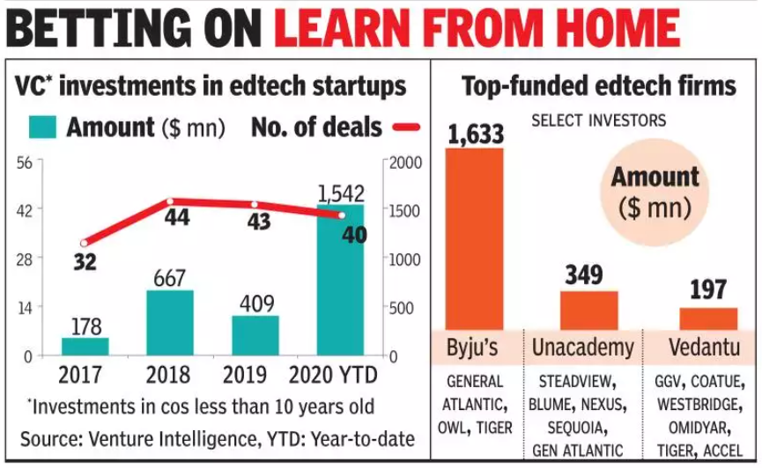

**Figure 8.1**

While well-established LearnTech industry have raised the most from investor like SoftBank, Tiger Global, Silver Lake and General Atlantic, more action is expected to continue as adoption of companies in LearnTech have also been able to build an international revenue base, and some are expected to turn profitable. For instance, code-learning start up WhiteHat Jr gets the majority of its revenues from overseas. Mr. Bajaj founder of WhiteHat Jr. never told the net worth for customer acquisition cost in mobile apps and site setup but he surly share the approximate value of WhiteHat Jr was spending about $119 per user in India. After the acquisition that it is considering experimenting with TV ads, Newspaper advertisement, Posters, Flyers, etc. Only 60% people used to show up for a class booking.

**EXPENDITURE:**

* **Bootstrapping**

Paying for the startup with your own money is risky, but gives you the ultimate control over all the decisions, as no one else has a stake in the business. However, getting the necessary amount can be problematic.

* **Loans**

Almost every bank can lend you money to start your own business. But there are also state and governmental initiatives that can make getting funds a bit easier. You have to pay the loans back with interest even if the business fails, might have to provide collateral, and carry a personal litigation risk (if you default). But managing loans payment is straightforward (fixed monthly payments), the lender doesn’t have any control over your business, and the interest payments can be deducted as expenses.

* **Investment**

Investors can give you money in exchange for a stake in your company - if they find your idea viable, that is. If you get investor funding, you might also get mentoring, networking, and other help (especially in case of accelerators), repayment is more flexible, and if the startup has to close, you don’t have to give the investment money back.

* **Grants**

As education is something that is considered to make the world a better place, there are organizations that support educational initiatives. There are also general-purpose grants that are available to the businesses regardless of the industry. You don’t have to pay the grants back, however, your business needs to fit the specific grant’s requirements.

* **Crowdfunding**

Since 2016, crowdfunding equity has surpassed the investment one. Under this model a large number of people contribute relatively small sums in exchange for a gift or a non-monetary bonus once the product or service is live. Crowdfunding allows you to remain in control of your business, great for pitching niche ideas, and can bring you money in a matter of a month. However, you need to invest in marketing to attract donors, must have a clear proposition, and if the crowd doesn’t pledge enough funds, you get nothing.

* **Content development**

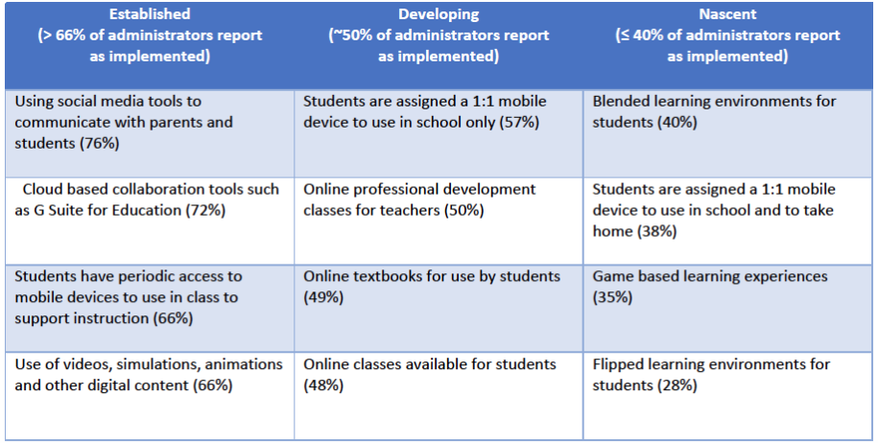Consulting services can help you plan your gamification strategy, software architecture, monetization, and other facets of the new product. E-Learning content for your product includes anything from text-based lessons to interactive videos and learning games.

**Figure 8.2**

For LearnTech start up you can either hire a dedicated team or manage it yourself, order a full-cycle product development, or anything in-between. In starting of WhiteHat Jr start-up, a group of 1,000 teachers & 150 management member are formed.

Company gave flexibility of working hours, the incentives given from time to time apart from the pay and the health care benefits, for WhiteHat Jr’s Faculties & management.

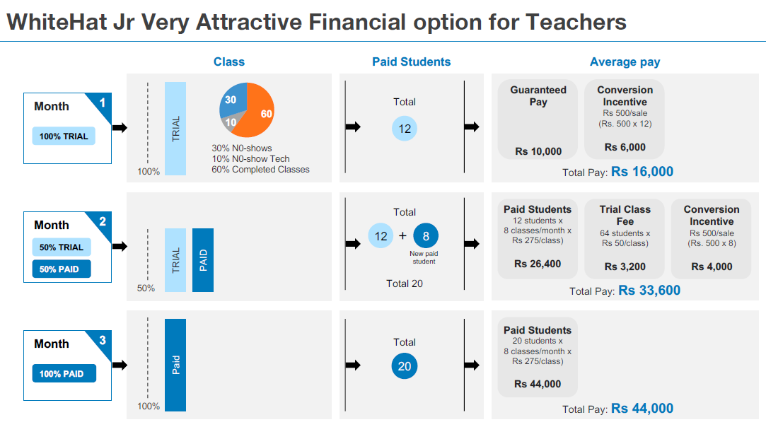Minimum Guarantee Pay-out for initial 3 months, until you have your own paid students and your income is stable after 3 months.

**Figure 8.3**

**REVENUE:**

India’s earliest and most valuable LearnTech startup BYJU’S saw 7.5 million new users on its platform since it started offering free access to content. In April alone, the Bengaluru-based firm grossed Rs 350 crore in revenue.

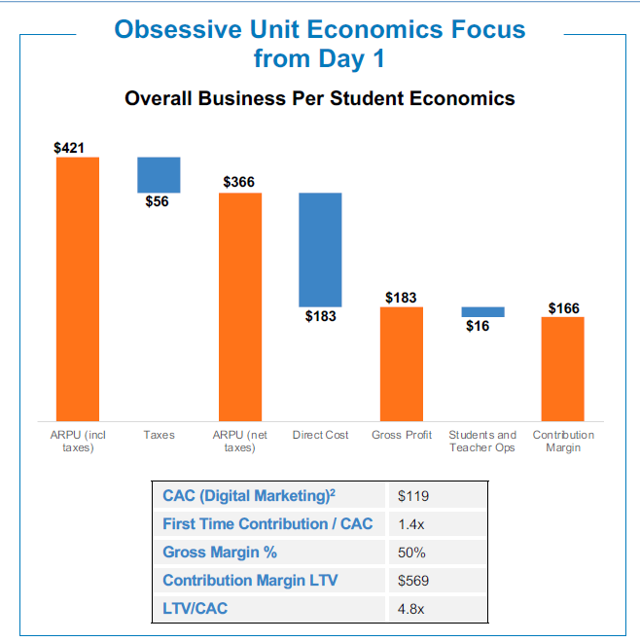This LearnTech startup has seen its revenue soar 400 percent in FY20. It recorded the highest growth in terms of monthly revenue in the lockdown months of April and May, expanding 30 percent over the March number

**Figure 8.4**

In 2018, Mr Bajaj started WhiteHat Jr, an online educational company w.At its initial stage, the company secured funding from Nexus Venture Partners, Omidyar Network and Owl Ventures. In 2020, WhiteHat Jr. was acquired for $300 million by BYJU'S, one of the largest online educational companies in India. As a result, the company was integrated in BYJU'S coding teaching division.

WhiteHat Jr's estimated annual revenue is currently $435.3M per year and estimated revenue per employee is $165,000.

WhiteHat Jr has currently 2638 Employees which grew their employee count by 782% last year.

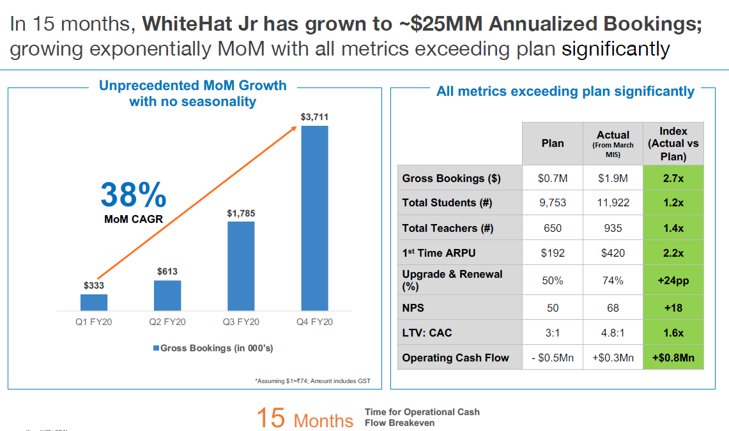

**Figure 8.5**

Unlike most LearnTech start-ups, WhiteHat Jr. assigns one teacher to each student. These classes are live and each session costs about $10, More than 5,000 teachers currently work with WhiteHat Jr.

WhiteHat Jr the only Indian company to reach such a deal in just 15 months.

In the midst of the coronavirus pandemic, WhiteHat Jr is growing 100 percent month on month in India as well as the US. Founded in November 2018, it has a revenue run rate of $150 million and 65,000 paid students per month.

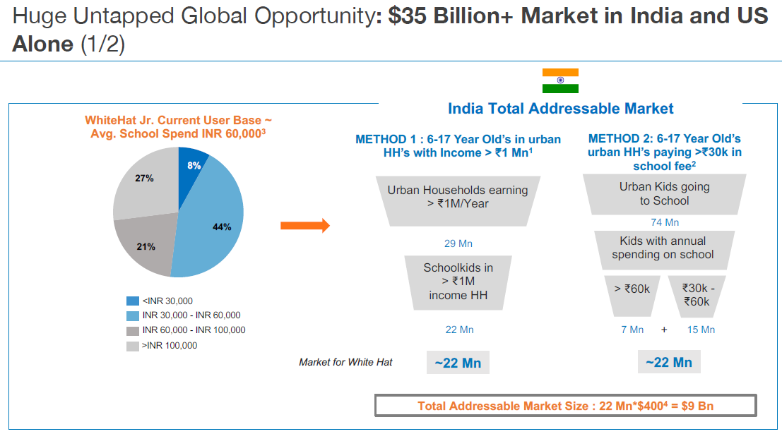

**Figure 8.6**

1. **DESCRIPTION OF PRODUCT**

WhiteHat Jr. is one of the world’s leading tech Curriculum for kids. Kick start the coding journey to create the next billion-dollar idea of the tech world is the moto of this company.

**Figure 9.1**

WhiteHat Education Technology Private Limited ("Company", “We” or “Us” and their connotations) operates a website (URL: https://www.whitehatjr.com) (together called as “Platform”) which is engaged in the service of online tutoring computer science to children.

The Company facilitates online computer science education services to children. WhiteHat Jr’s aim at providing lessons on programming and coding languages to the Child. The concept is to create a virtual classroom, which helps the Child to learn without any restrictions on time and place.

The Company will have its sets of modules according to which the Child is expected to complete their levels. The Company has tutors who will be assisting the Child with their modules.

Company offers You and the Child the opportunity to submit, post, display, transmit, perform, publish, distribute or broadcast content and materials, including, without limitation, articles, commentaries, photographs, text, music, video, audio recordings, computer graphics, pictures, data, questions, comments, suggestions or personally identifiable information. We do not encourage your Child to post any Personal Information.

However, for accessing the Services, the Child or You may have to create an account and disclose ("Personal Information").

The Platform is a paid service and the payments made by you shall be according to the plans opted by you through the Platform. All payments by Users shall be through the payment mechanism put in place by us. Users have been given various options to choose and proceed with the payment (i.e., Card Payment facilities, EMI Payment, Online Bank Transfer and Wallet Payment).

WhiteHat Jr. sub-divided the stage of learning according t0 the students’ age group. There are 5 stages Beginner (Grade 1), Intermediate (Grade 2-3), Advanced (Grade 4-6), Professional (Grade 7-9) and Applied Tech (Grade 10+). The courses and fee for per course is described below table,

|  |  |  |  |
| --- | --- | --- | --- |
| **Name of a Plans** | **Description** | **Price of Per Class** | **Total Amount** |
| Beginner  (Grade 1) | Introduction of coding:  (Sequence, Fundamentals Coding Blocks, Loops),  Introduction of coding + App Developer Certificate:  (Events / UI, Conditionals, Complex Loop, Logic Structures, Turtle Coding)  Introduction of coding + App Developer Certificate + Advance Coding with space Tech: (Extended UI/UX, Rich GUI app, Space Tech simulation in Space Lab / Game Lab, Professional Game Design) | Rs. 750  Rs. 708  Rs. 694 | Rs. 5,999  Rs. 33,999  Rs. 99,999 |
| Intermediate  (Grade 2-3) | Introduction of coding:  (Sequence, Fundamentals Coding Blocks, Loops),  Introduction of coding + App Developer Certificate:  (Events / UI, Conditionals, Complex Loop, Logic Structures, Turtle Coding)  Introduction of coding + App Developer Certificate + Advance Coding with space Tech: (Extended UI/UX, Rich GUI app, Space Tech simulation in Space Lab / Game Lab, Professional Game Design) | Rs. 750  Rs. 708  Rs. 694 | Rs. 5,999  Rs. 33,999  Rs. 99,999 |
| Advanced  (Grade 4-6) | Introduction of coding:  (Sequence, Fundamentals Coding Blocks, Loops),  Introduction of coding + App Developer Certificate:  (Events / UI, Conditionals, Complex Loop, Logic Structures, Turtle Coding)  Introduction of coding + App Developer Certificate + Advance Coding with space Tech: (Extended UI/UX, Rich GUI app, Space Tech simulation in Space Lab / Game Lab, Professional Game Design) | Rs. 750  Rs. 708  Rs. 694 | Rs. 5,999  Rs. 33,999  Rs. 99,999 |
| Professional  (Grade 7-9) | Introduction of coding:  (Sequence, Fundamentals Coding Blocks, Loops),  Introduction of coding + App Developer Certificate:  (Events / UI, Conditionals, Complex Loop, Logic Structures, Turtle Coding)  Introduction of coding + App Developer Certificate + Advance Coding with space Tech: (Extended UI/UX, Rich GUI app, Space Tech simulation in Space Lab / Game Lab, Professional Game Design) | Rs. 750  Rs. 708  Rs. 694 | Rs. 5,999  Rs. 33,999  Rs. 99,999 |
| Applied Tech  (Grade 10+) | Introduction To Python (Python Basics-Loops, conditionals, lists, functions & Numpy Array, Make AI based Games)  Introduction To Python + Data Analytics Certification: (Data Processing & Analytics (Classification & Forecasting, Forecasting applications Searching Exo-Planets Earth Observation))  Introduction To Python + Data Analytics Certification + Advance Coding with Space Tech: (Deep Learning, Computer Vision & Natural Language Processing, Life –Tech: Predict Disease & more ) | Rs. 750  Rs. 708  Rs. 694 | Rs. 5,999  Rs. 33,999  Rs.99,999 |

**Table 9.1**

After completing all the procedure the selected course is unlock and you and your young once can access to the skills.

1. **CONCLUSION:**

The industry doesn’t need yet another average classroom management tool or learning management system. We need to be different and make the best use of innovative tools and services to stand out in this already crowded market.

It is important to keep in mind that change in the education industry does not come easy. So we have to present a strong case to doubtful decision-makers.

Offering free products and services to the end users, along with exploring alternate monetization options through partnerships & other models, can help students to get material in one place.

In Tier III and Tier II cities E-learning tools can solve their problem by letting them hold one-on-one interactions with senior students or subject experts over the cyberspace. Weather it a problem of language or problems with internet usage .LearnTech companies are actively working to solve the vernacular problem.

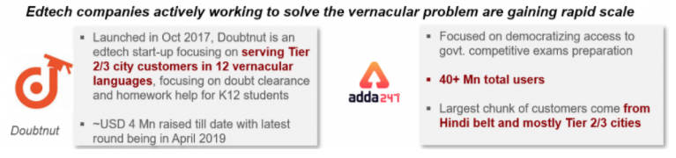

**Figure 10.1**

In this way, online engagement gives a student a way out of the limiting classroom environment to get their queries resolved on their own terms as suits them best without them having to follow rigid classroom schedules that run on express speed. It is necessary to showcase the usefulness of our product and focus on its innovative features that aim to enhance learning.

It is essential for startups to demonstrate that their technologies are completely safe and secure. For that we have to help them to understand that crucial data will not be lost anywhere in the process.

As a responsible startup, it is our duty to demonstrate the real value and benefits of LearnTech technology.

**REMARKS :**

**SIGNATURE DATE**